**Minutes of UUFC Board of Trustees Meetings in 2006**

**Sandy Chubon, Secretary, January - June 2006**

**Jessica Kross, Secretary, July - December 2006**

**Contents:**

**January 11, 2006 Board Meeting**

**February 8, 2006 Board Meeting**

**March 8, 2006 Board Meeting**

**April 12, 2006 Board Meeting**

**April 18, 2006 Board Meeting**

**April 29, 2006 Board Meeting**

**May 10, 2006 Board Meeting**

**June 14, 2006 Board Meeting**

**July 12, 2006 Board Meeting**

**August 9, 2006 Board Meeting**

**September 13, 2006 Board Meeting**

**October 11, 2006 Board Meeting**

**November 8, 2006 Board Meeting**

**December 13, 2006 Board Meeting**

|  |
| --- |
| * |

|  |
| --- |
| * |

|  |
| --- |
| * |

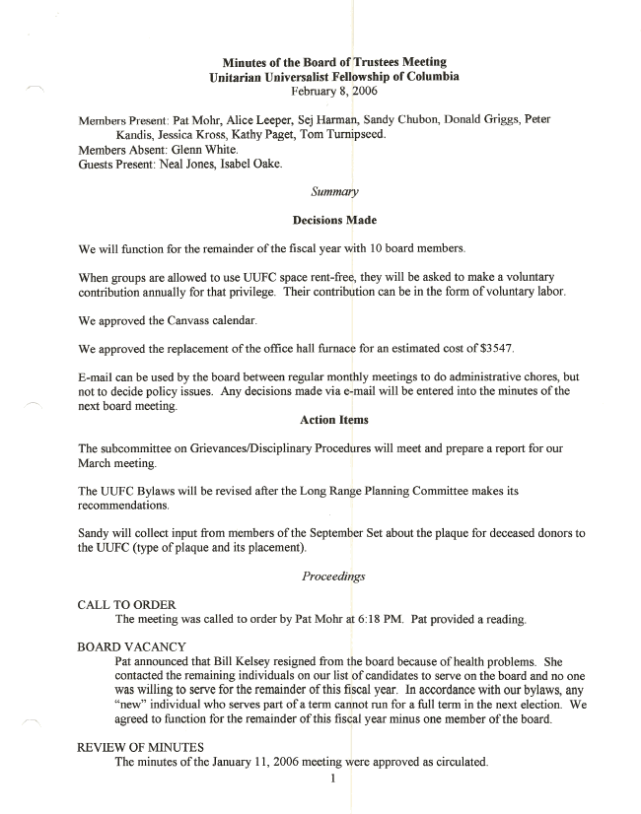

|  |
| --- |
| * |

|  |
| --- |
| * |

|  |
| --- |
|  |

**Minutes of the Board of Trustees Meeting Unitarian Universalist Fellowship of Columbia March 8, 2006**

Members Present: Pat Mohr, Alice Leeper, Sej Harman, Sandy Chubon, Donald Griggs, Peter Kandis, Jessica Kross, Kathy Paget, Tom Turnipseed, Glenn White.

Guests Present: Neal Jones, Isabel Oake, Carita Barr, Judy Turnipseed.

*Summary*

**Motions Passed**

The Board adopted a Policy Regarding Disruptive Behavior.

Supervisors will send their recommendations for employee's salaries to the Finance Committee with a copy to the Chair of the Personnel Committee.

**Decisions Made**

We will defer a decision on replacing/repairing the heating/cooling system until after the Long Term Planning Committee reports to the Board.

Action Items

Neal will prepare an article for the Unigram about the new policy regarding disruptive behavior.

*Proceedings*

CALL TO ORDER

The meeting was called to order by Pat Mohr at 6:20 PM. Alice Leeper provided a reading.

REVIEW OF MINUTES

Glenn White noted that he was not present at the February meeting. With that correction, the minutes of the February 8 meeting were approved.

REPORTS

Administrator- The representative of the heating company came to give an estimate for replacing the heating/cooling system. He asked what our plans are for the long-term future of the building: would we be adding on to the building or doing any major remodeling? Isabel was not able to answer his questions and he could not give an estimate without that information. The question of replacing/repairing the heating system will be addressed after we get the report from the Long Range Planning Committee.

Co-Council - Committee Chairs are enthused about their plans for a committee fair, planned for the Sunday when we have ingathering of waters (late summer). Tables will be set up in the social hall for each committee to recruit new members. Food will be a part ofthe event.

Finance- We are behind on pledge income. It is time for the Finance Committee to send out quarterly notices to members which will notify them if they are behind.

I

Donald reported that the process is in place to have our phone service changed to the new service. It takes a long time to complete that process.

A question was raised about whether our Endowment monies are included in the monthly reports. They are not. That account has about $4,000 and is earning interest.

CANVASS

Peter presented this year's canvass giving guide. It includes four levels of giving: supporter, sustainer, visionary, and full tithe. Members/friends will be asked to indicate which category their pledge represents. Peter would like to develop an estimate of the income we could expect from our congregation to set the goal for pledges. Sej and Kathy agreed to assist in that effort.

DRE SEARCH

We ran an ad in the State on Sunday (very expensive). We have received several applications and some additional inquiries. We will keep the search open through March.

GRIEVANCE/DISCIPLINE POLICIES

The subcommittee (Sej, Jessica, and Kathy) has completed work on these documents which will be added as appendices to the Employee Handbook after board approval. They will circulate copies to all board members before our next meeting.

PAYMENT OF TJD & UUA DUES

We budgeted $4,000 for dues this year. Our fair share will be about $8,000. Our fair share for next year (06-07) will be about $12,000. Isabel makes quarterly payments and forwards pass-through amounts that members have designated for dues.

POLICY REGARDING DISRUPTIVE BEHAVIOR

Neal presented this policy developed by a taskforce of: Neal Jones, Mary Etta McCarthy, Regina Moody, Janet Swigler, and Glenn White. The policy is adapted from one written by the UUA and incorporates our UU Principles and our UUFC Covenant. Alice moved that we adopt the policy; Kathy seconded the motion. The motion passed. Neal agreed to write an article for the Unigram describing the policy.

SALARY RECOMMENDATION PROCESS

Pat noted that the process for making salary recommendations for employees is as follows: the supervisor sends a recommendation to the personnel committee who then forwards their recommendation to the finance committee. Pat suggested streamlining the procedure for this year to have the supervisor send a recommendation to the finance committee with a copy to the personnel committee chair. Jessica moved that Supervisors will send their recommendations for employee's salaries to the Finance Committee with a copy to the Chair of the Personnel Committee. Peter seconded. The motion passed.

ADDITIONAL MEETING

The Board agreed to meet on April 18 to review the budget for next year.

ADJOURNMENT

The meeting adjourned at 8 :20 PM. The Board then met in executive session.

Minutes recorded by Sandy Chubon

|  |
| --- |
| * |

|  |
| --- |
| * |

|  |
| --- |
| * |

|  |
| --- |
| * |

|  |
| --- |
| * |

|  |
| --- |
| * |



  
  
  

  
  
  

  
  
  

  
  
  

  
  
  

  
  
  

  
  
  

  
  
  

  
  
  

  
  
  

  
  
  

  
  
  

  
  
  

  
  
  

  
  
  

  
  
  

  
  
  

  
  
  

  
  
  

  
  
  

  
  
  

  
  
  

  
  
  